## Front End Engineering-II

Project Report

Semester-IV (Batch-2022)

Interactive E-commerce Platform

**Supervised By: Submitted By:**

Preenu Mittan Ansh Gupta (2210991295)

Group - 17

**Department of Computer Science and Engineering**

## Chitkara University Institute of Engineering & Technology,

## Chitkara University, Punjab

**Institute Name** **Chitkara University Institute of Engineering and Technology**

**Department**  **Department of Computer Science & Engineering**

**Programme**  **Bachelor of Engineering (B.E.), Computer Science & Engineering**

**Course Name** **Front end Engineering Session 2024-25**

**Course Code** **22CS014** Semester/Batch **4th /2022**

**Group No** **G17**

**FacultyName:** **Ms. Preenu Mittan**

**ABSTRACT**

The emergence of digital technologies has revolutionized the way businesses operate, particularly in the realm of commerce. With the advent of interactive e-commerce websites, businesses have been provided with a powerful platform to engage customers, streamline transactions, and enhance user experience. This project report delves into the development and implementation of an interactive e-commerce website, aiming to provide a comprehensive understanding of its functionalities, design principles, and the underlying technologies utilized.

The report begins by exploring the significance of interactive e-commerce websites in today's digital landscape, highlighting their role in fostering customer engagement and driving sales. It proceeds to outline the objectives and scope of the project, emphasizing the importance of creating a user-centric platform that seamlessly integrates innovative features and intuitive navigation.

Throughout the project, emphasis is placed on leveraging cutting-edge technologies such as responsive web design and personalized recommendation systems to enhance the overall user experience. Additionally, considerations regarding scalability, performance optimization, and data security are meticulously addressed to ensure the website's robustness and reliability.

**Table of Contents**

|  |  |  |
| --- | --- | --- |
|  |  |  |
|  | **Introduction** | **5** |
|  | **Background** | **6** |
|  | **Objectives** | **6-7** |
|  | **Significance** | **7** |
|  | **Problem** **Defination** | **8** |
|  | **Requirements** (**Hardware** **&** **Software** | **8-9** |
|  | **Solution & Key features** | **10** |
|  | **Proposed Design & Project Structure** | **11** |
|  | **Schematic Diagram** | **12** |
|  | **Algorithms Used** | **13** |
| 11  11 | **Snapshots of Project** | **14-22** |

1. **Introduction**

In today's digital era, the landscape of commerce is continually evolving, with businesses increasingly turning to online platforms to reach and engage with customers. The emergence of interactive e-commerce websites represents a pivotal shift in how businesses interact with their target audience, offering a dynamic and immersive online shopping experience. This introduction serves as a primer to delve into the development and implementation of an interactive e-commerce website, exploring its background, objectives, significance, and methodology.

The advent of the internet has significantly transformed the way commerce operates, revolutionizing traditional business models and paving the way for innovative online platforms. In this digital age, where consumers expect seamless and personalized experiences, e-commerce has emerged as a cornerstone of modern retail. However, as the digital landscape continues to evolve, merely having an online presence is no longer sufficient. Businesses must now strive to provide engaging and interactive experiences to capture the attention and loyalty of their target audience.

The project sets out with the primary objective of addressing the evolving needs and expectations of online consumers. By incorporating interactive elements such as immersive product displays, personalized recommendations, and social engagement features, the website seeks to enhance user engagement and satisfaction. Additionally, the project places a strong emphasis on user-centric design principles, ensuring that the website is intuitive, accessible, and visually appealing across various devices and screen sizes.

**1.1 Background**

The proliferation of internet access and the widespread adoption of smartphones and other digital devices have fundamentally transformed consumer behavior. With an ever-growing number of individuals turning to online channels for their shopping needs, businesses are compelled to adapt their strategies to meet the demands of this digital marketplace. Traditional brick-and-mortar stores are increasingly supplemented, if not replaced, by e-commerce platforms that offer convenience, accessibility, and a diverse array of products and services.

In this context, the development of interactive e-commerce websites becomes imperative for businesses seeking to remain competitive and relevant in the digital age. These websites go beyond merely facilitating transactions; they serve as immersive hubs where customers can explore products, interact with brands, and make informed purchasing decisions. Through intuitive interfaces, personalized recommendations, and seamless integration of multimedia elements, interactive e-commerce websites aim to replicate, and in some cases enhance, the experiential aspects of traditional retail environments.

**1.2 Objectives**

The primary objective of this project is to design, develop, and implement an interactive e-commerce website that caters to the evolving needs and preferences of online shoppers. Key objectives include:

1. User-Centric Design: To create an intuitive and visually appealing user interface that enhances navigation, encourages exploration, and facilitates seamless transactions.
2. Innovative Features: To integrate cutting-edge features such as personalized product recommendations, interactive product visualization, and social shopping capabilities to enrich the user experience.
3. Scalability and Performance: To ensure that the website is scalable to accommodate growing user traffic and optimized for performance to deliver fast and responsive browsing experiences.
4. Security and Reliability: To implement robust security measures, including secure payment gateways and data encryption, to safeguard user information and instill trust in the platform.
5. Evaluation and Feedback: To solicit feedback from users through usability testing, surveys, and analytics, and iteratively improve the website based on insights gathered.
6. Analyze the current landscape of e-commerce: Conduct a comprehensive review of existing interactive e-commerce websites, identifying trends, challenges, and opportunities in the digital marketplace.
7. Evaluate technology stack and implementation strategies: Assess various technologies and platforms suitable for developing an interactive e-commerce website, considering factors such as scalability, security, and performance.
8. Document insights and recommendations: Summarize the findings of the project, including lessons learned, challenges encountered, and recommendations for future enhancements or iterations of the interactive e-commerce website.

**1.3 Significance**

The significance of this project lies in its potential to redefine the way businesses engage with customers in the digital realm. By leveraging the capabilities of interactive e-commerce websites, businesses can forge deeper connections with their target audience, drive sales, and differentiate themselves in a crowded marketplace. Moreover, the project contributes to the body of knowledge surrounding e-commerce website development, providing valuable insights and best practices for businesses seeking to establish or enhance their online presence.

In the subsequent sections of this report, we will delve into the methodology employed to achieve these objectives, detailing the design, development, implementation, and evaluation phases of the interactive e-commerce website. Through a comprehensive analysis, we aim to showcase the effectiveness and impact of this innovative platform on enhancing the online shopping experience and driving business growth.

1. **Problem Definition and Requirements**

Traditional e-commerce platforms rely on static product pages and limited search options, making it difficult for customers to engage deeply with products. So, develop an interactive e-commerce platform that bridges the gap between passive browsing and active engagement. Hence,

1. There is a need for an interactive e-commerce platform that bridges the gap between passive browsing and active engagement, offering innovative features and functionalities to enhance the overall shopping experience.
2. The lack of interactivity on traditional e-commerce platforms may lead to missed opportunities for businesses to showcase their products effectively and establish meaningful connections with customers.
3. In the competitive landscape of e-commerce, businesses need to differentiate themselves by offering engaging and interactive experiences that captivate the attention of customers and drive conversions.
4. Addressing these challenges requires the development of an interactive e-commerce platform that leverages cutting-edge technologies and user-centric design principles to create immersive and engaging shopping experiences.

**2.1 Requirements**

Hardware and Software Requirements for Interactive E-commerce Platform:-

Building a E-commerce Platform requires careful consideration of both hardware and software components to ensure optimal performance, scalability, and security. Here's a breakdown of the hardware and software requirements for such a system:

**2.1.1 Hardware Requirements:**

1. Computer/Laptop: Any standard computer or laptop capable of running Visual Studio Code.
2. Processor: A modern processor (dual-core or higher) for smooth performance while coding.
3. RAM: At least 4GB of RAM to handle the frontend development environment efficiently.
4. Storage: Adequate storage space for storing project files, IDE, and related software (at least 128GB recommended).
5. Display: A display with a minimum resolution of 1366x768 for comfortable coding and previewing.
6. Input Devices: Keyboard and mouse or trackpad for input.
7. Internet Connectivity: Stable internet connection for accessing online resources, libraries, and testing the website in different browsers.
8. Backup: Regular backup solution for project files to prevent data loss.

**2.1.2 Software Requirements:**

1. Operating System: Compatible operating system such as Windows, macOS, or Linux.
2. Text Editor/IDE: Visual Studio Code (VS Code) for writing HTML, CSS, and JavaScript code.
3. Web Browser: Latest versions of popular web browsers like Google Chrome, Mozilla Firefox, or Safari for testing and debugging the frontend.
4. Version Control System: Git for version control to manage code changes and maintain project history.
5. CSS Framework: Bootstrap for creating responsive and visually appealing frontend designs.
6. Graphics Software: Optional graphics software like Adobe Photoshop or Adobe Illustrator for creating visual assets if needed.
7. Local Server: A local server environment (such as XAMPP, MAMP, or WAMP) for previewing the frontend website locally.
8. FTP Client: An FTP client (File Transfer Protocol) for uploading frontend files to the web server if necessary for deployment.
9. **Solution**

The traditional e-commerce platforms often lack interactivity, leading to passive browsing experiences for customers. To address this issue, we propose the development of an interactive e-commerce platform that fosters active engagement with products. This platform will utilize modern web technologies and user-centered design principles to bridge the gap between passive browsing and active engagement, thereby enhancing the overall shopping experience.

**3.1 Key Features**

1. **Interactive Product Pages:** Enhance product pages with interactive elements such as zoom-in functionality, product videos, and user-generated content(reviews, ratings,)These interactive features will provide customers with a comprehensive understanding of the product.
2. **Dynamic Search Functionality:** Implement a dynamic search feature allowing users to quickly find products by name, category, brand, or any other relevant attribute. Utilize efficient search algorithms such as binary search to provide real-time search results, enhancing user experience and facilitating product discovery.
3. **Real-Time Cart Management:** Enable users to add, remove, and modify items in their shopping cart in real-time without page reloads.
4. **Interactive Filtering Options:** Incorporate interactive filtering options allowing users to refine product listings based on various attributes such as e.g., size, categories, condition. Implement filtering algorithms to dynamically update product listings based on selected filter criteria, enabling users find relevant products efficiently**.**
5. **Responsive Design with Media Queries:** Media Query Integration: Develop a responsive design using CSS media queries to ensure optimal viewing and interaction across various devices and screen sizes, including desktops, laptops, tablets, and smartphones.
6. **Secure Login Authentication:** Strengthen login authentication using local Storage to protect user credentials and prevent unauthorized access. Utilize session management techniques to maintain user authentication state securely throughout the browsing session
7. **Proposed Design / Methodology**

In this section, I will outline the proposed design and methodology for developing the frontend part of the e-commerce website for the fashion brand. This includes the overall structure of the project, the technologies used and the algorithms employed.

**4.1 Project Structure:**

The frontend part of the e-commerce website will follow a structured approach to ensure modularity, scalability and maintainability. The project structure will consist of the following key components:

1. HTML Pages : Separate HTML files for different sections of the website such as homepage, product pages, checkout pages, Blog page, About Page, FAQ Page.
2. CSS Stylesheets : External CSS files to maintain consistent across the website. Bootstrap framework will be utilized for responsive design and pre-built components.
3. Javascript Files: External Javascript files for implementing interactive features such as navigation menus, sliders, product filtering and searching , and login authentication.
4. Image Assets: Directory to store images including product images, logos, icons and background images.
5. Fonts: Directory to store custom fonts required for brand identity. I used Poppins and sans-serif fonts from googleleapis.com
6. Vendor Libraries: Directory to include third-party libraries such as bootstrap, boxicons.
7. Main Directory: The main directory will contain the index.html file as the entry point of the website, along with other supporting files like favicon.ico etc.

**4.2 Schematic Diagram:**

Below is a simplified schematic diagram illustrating the file structure of the frontend part of the e-commerce website:

- root

- assets

- css

- cart.css

- style.css

- swiper-bundle.min.css

- js

- main.js

- cart.js

- products.js

-swiper-bundle.min.js

- img

- index.html

- about.html

- blog.html

- cart.html

- contact.html

- details.html

- faq.html

- shop.html

**4.3 Algorithms Used :**

1. **Product Filtering Algorithm:** When a user selects specific criteria (e.g., size, categories, condition) for filtering products, JavaScript algorithms will be employed to dynamically update the product list based on the selected filters without reloading the page. This will enhance user experience by providing real-time results.
2. **Form Validation Algorithm:** JavaScript algorithms will be used to validate user input in forms (e.g., checkout form) to ensure that all required fields are filled correctly before submission. This will help in preventing errors and ensuring data integrity.
3. **Navigation Algorithm:** Algorithms will be implemented to handle navigation menus, dropdowns, and responsive navigation for different screen sizes. This will ensure smooth and intuitive navigation throughout the website.
4. **Search Algorithm:** Binary Search: Utilized for efficient searching of products within the catalog. Binary search operates by repeatedly dividing the search interval in half, narrowing down the possible matches until the target product is found or determined to be absent. This algorithm ensures quick retrieval of search results, optimizing the user experience.
5. **Real-Cart Feature Algorithm**: Shopping Cart Management Algorithm: Implemented to manage the addition, removal, and modification of products within the user's shopping cart. This algorithm maintains a data structure (e.g., array) to store the products along with their quantities. Operations such as adding a product, updating quantities, removing products, and calculating subtotal, taxes, and total are performed efficiently to provide a seamless shopping experience.
6. **Login Authentication Algorithm:** Authentication and Authorization Algorithm: Employed to verify the identity of users during the login process and grant appropriate access privileges based on their credentials. This algorithm validates user-supplied login credentials (username/email and password) against stored credentials in the local Storage .
7. **Results**

**5.1 Home Page**

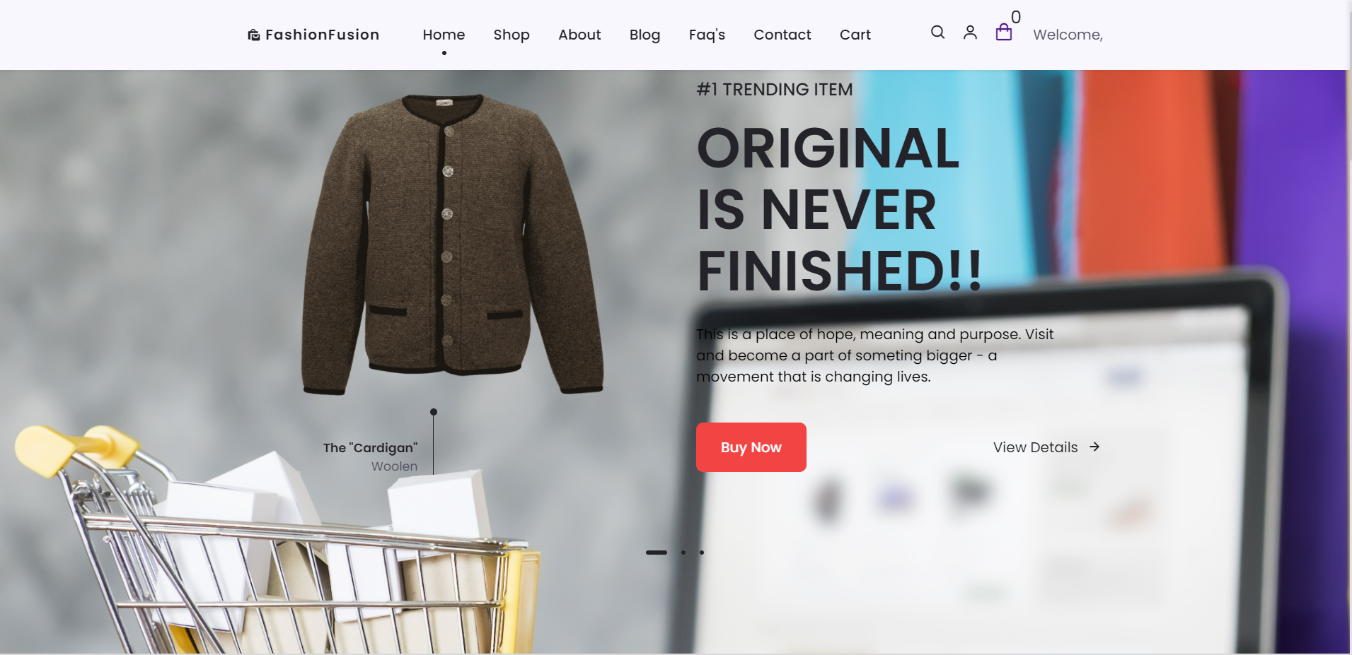

Figure 5.1 Home Page

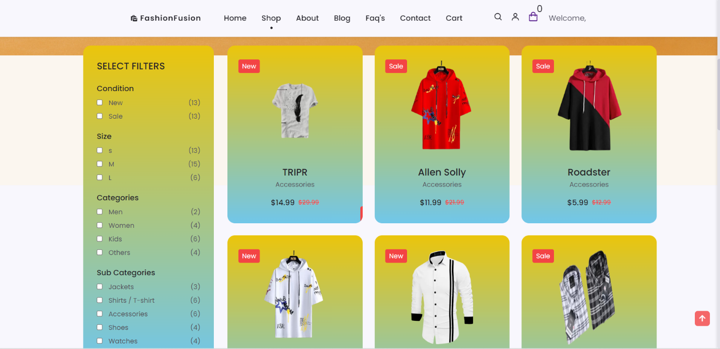 **5.2 Shop page**

Figure 5.2 Shop Page

**5.3 About Page**

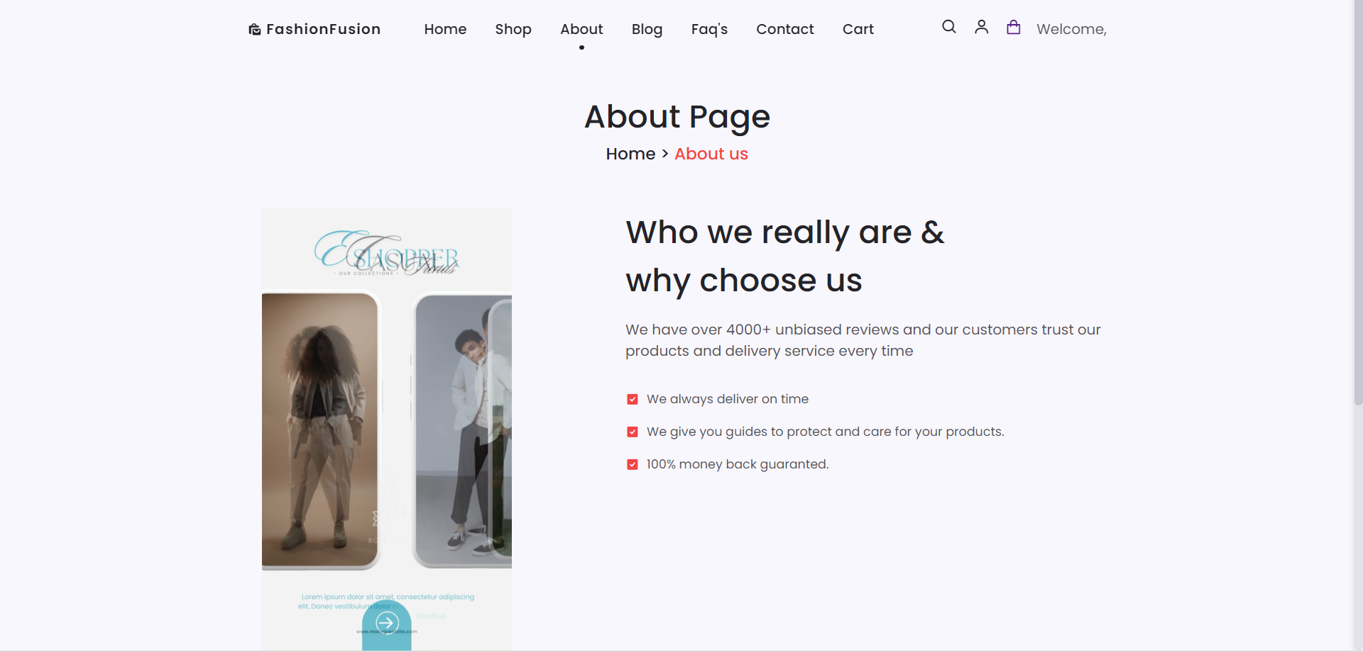

Figure 5.3 About Page

**5.4 Blog Page**

Figure 5.4 Blog Page

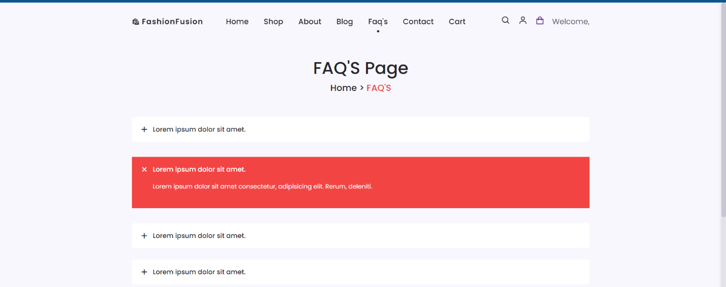 **5.5 FAQ’S Page**

Figure 5.5 FAQ’S Page

**5.6 Contact Page**

Figure 5.6 Contact Page

**5.7 Cart Page**

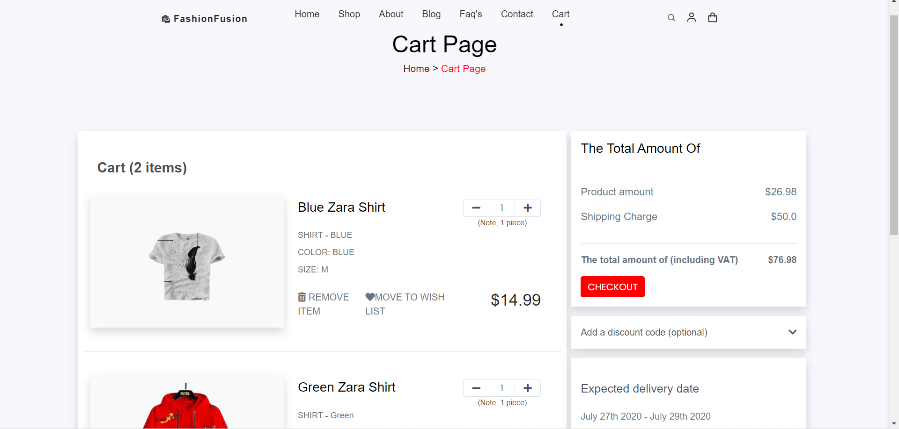

Figure 5.7 Cart Page

**5.8 Sign in Page 5.9 Sign up Page**

Figure 5.8 Login Page

Figure 5.9 Signup Page

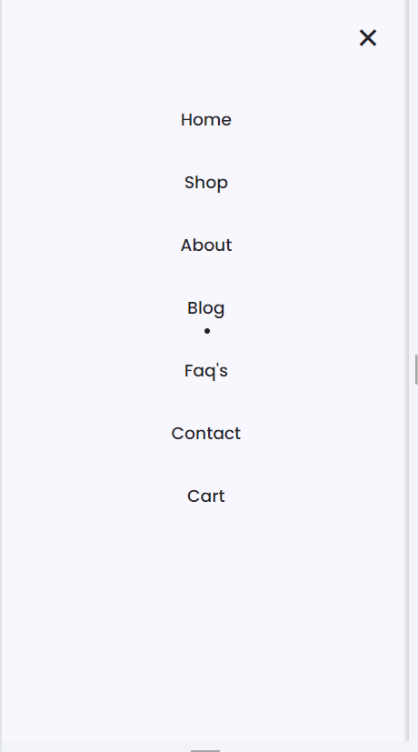**5.10 Responsiveness**

Figure 5.11 Responsive Menu Bar

Figure 5.10 Responsive Blog Page

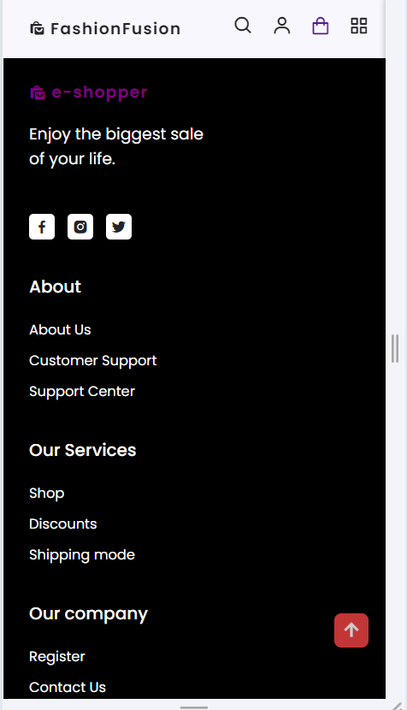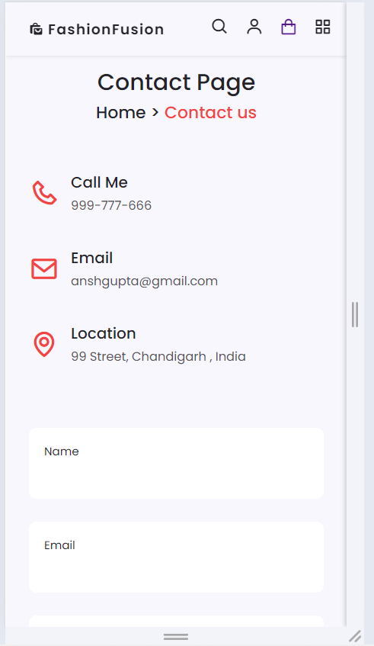

Figure 5.12 Responsive Menu Bar

Figure 5.13 Responsive Contact Page

**5.12 Search Functionality**

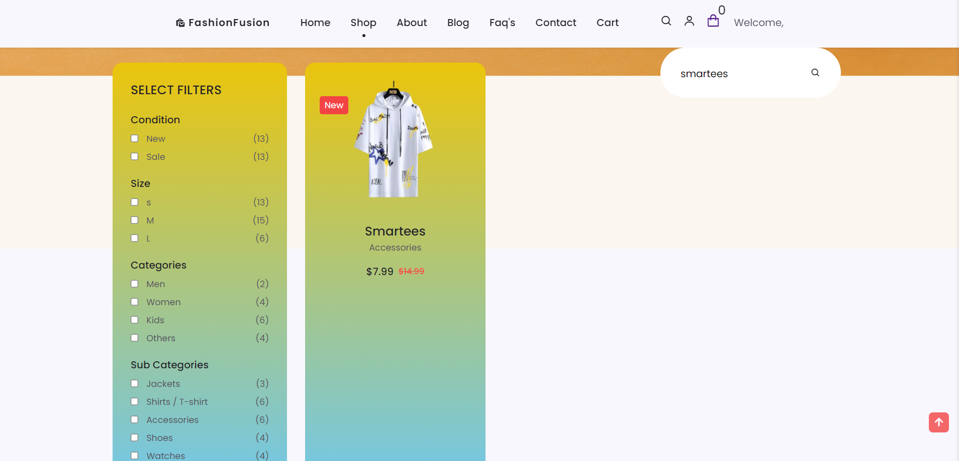

Figure 5.12 Searching Product by name

**5.13 Filter Functionality**

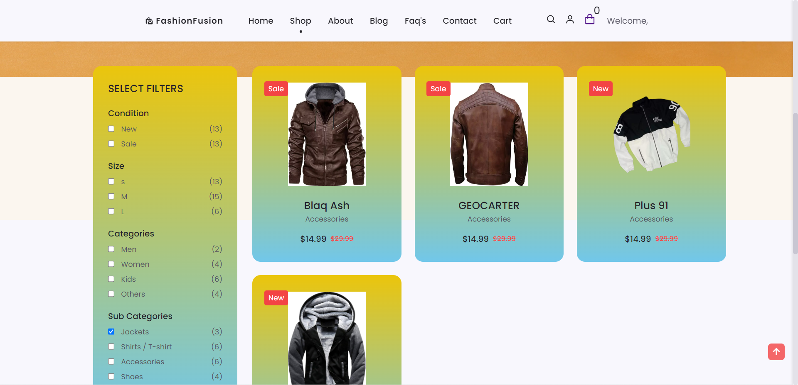

Figure 5.13 Filtering Product by condition

**5.14 Checkout Functionality**

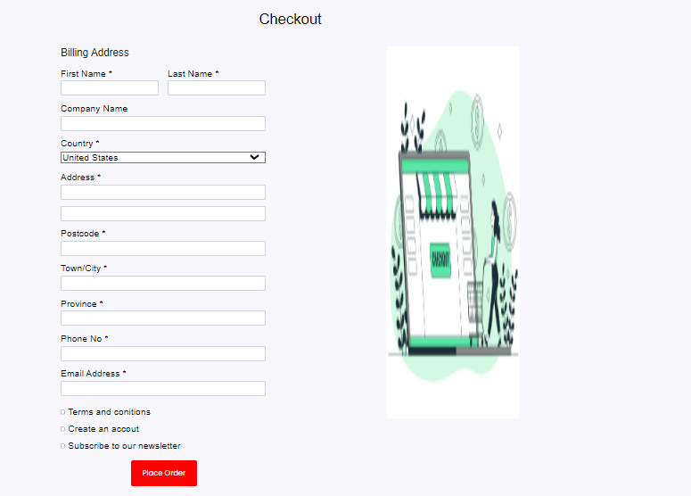

Figure 5.14 Checkout Functionality



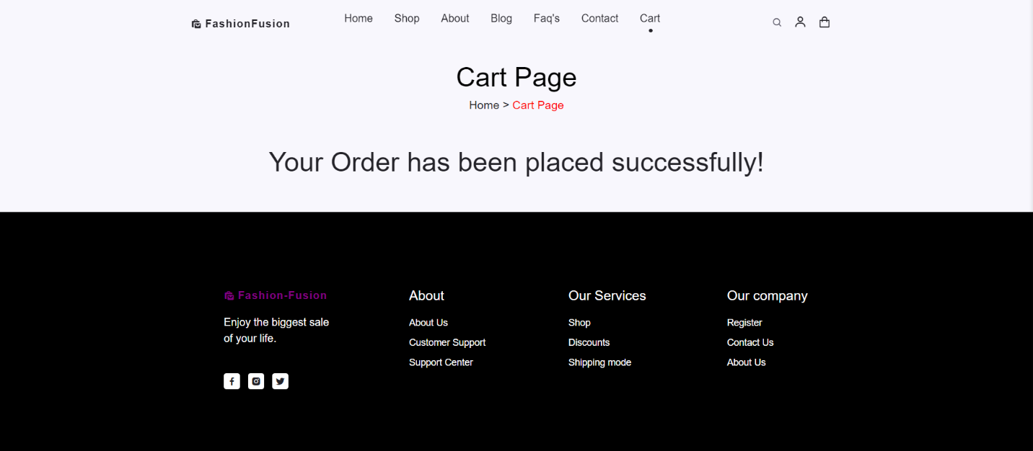



Figure 5.15 Order Placed

**5.15 Signing up**

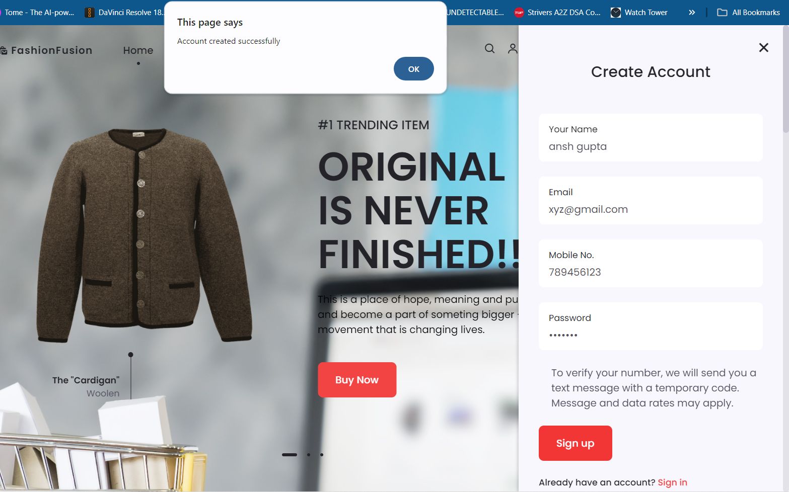

Figure 5.15 Creating Account

**5.16 Signing in**

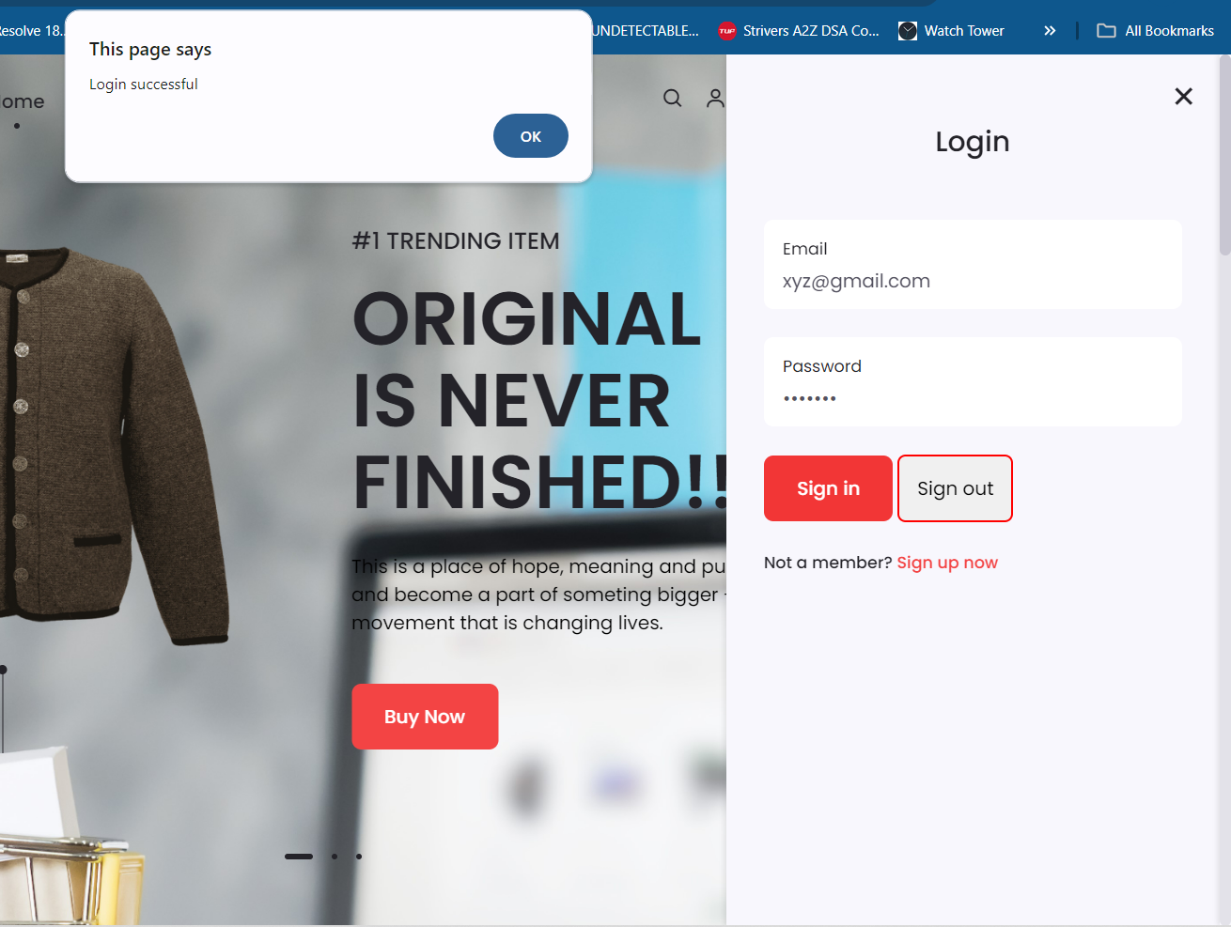

Figure 5.16 Login To Account



Figure 5.16 Signed up

1. 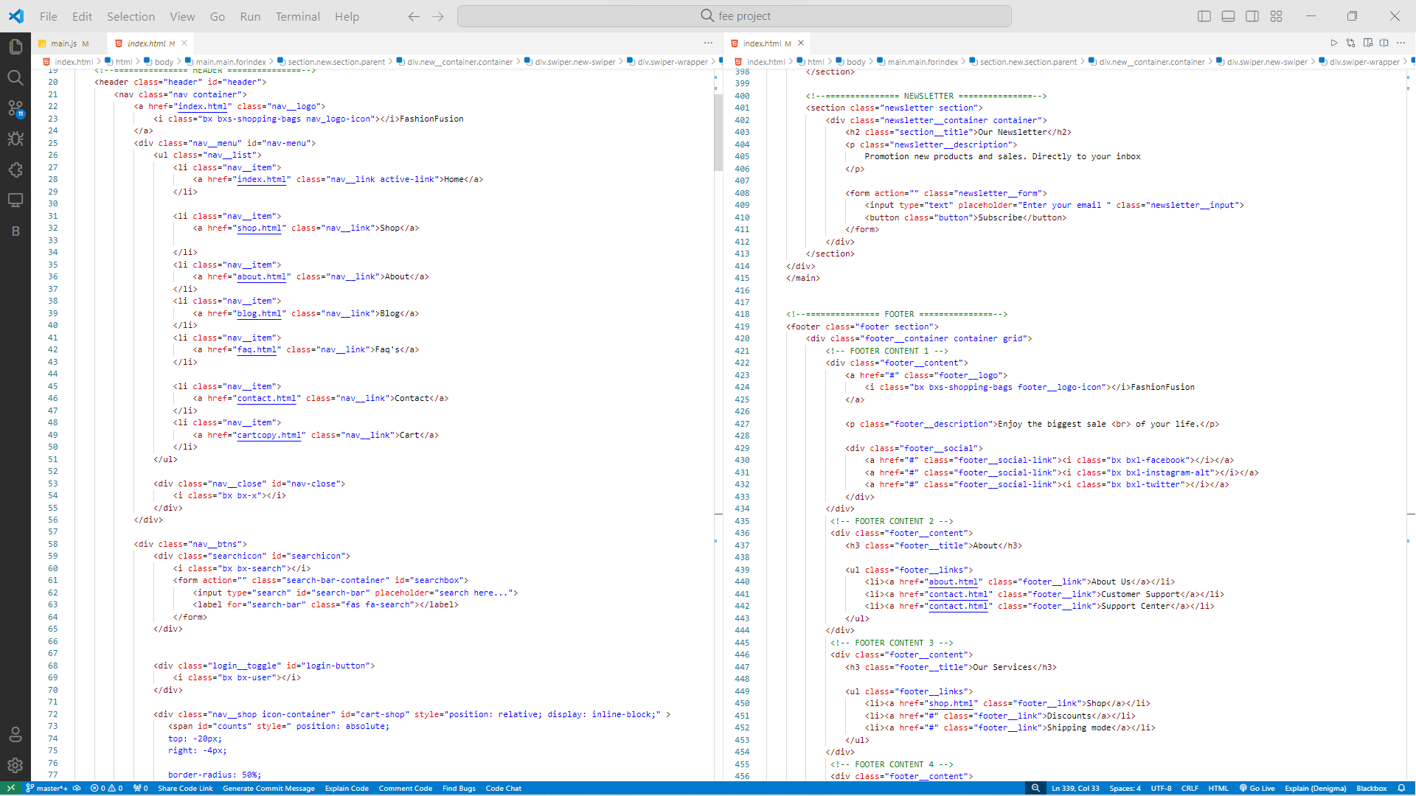**Code Snapshots**

Figure 6.1 Index.html

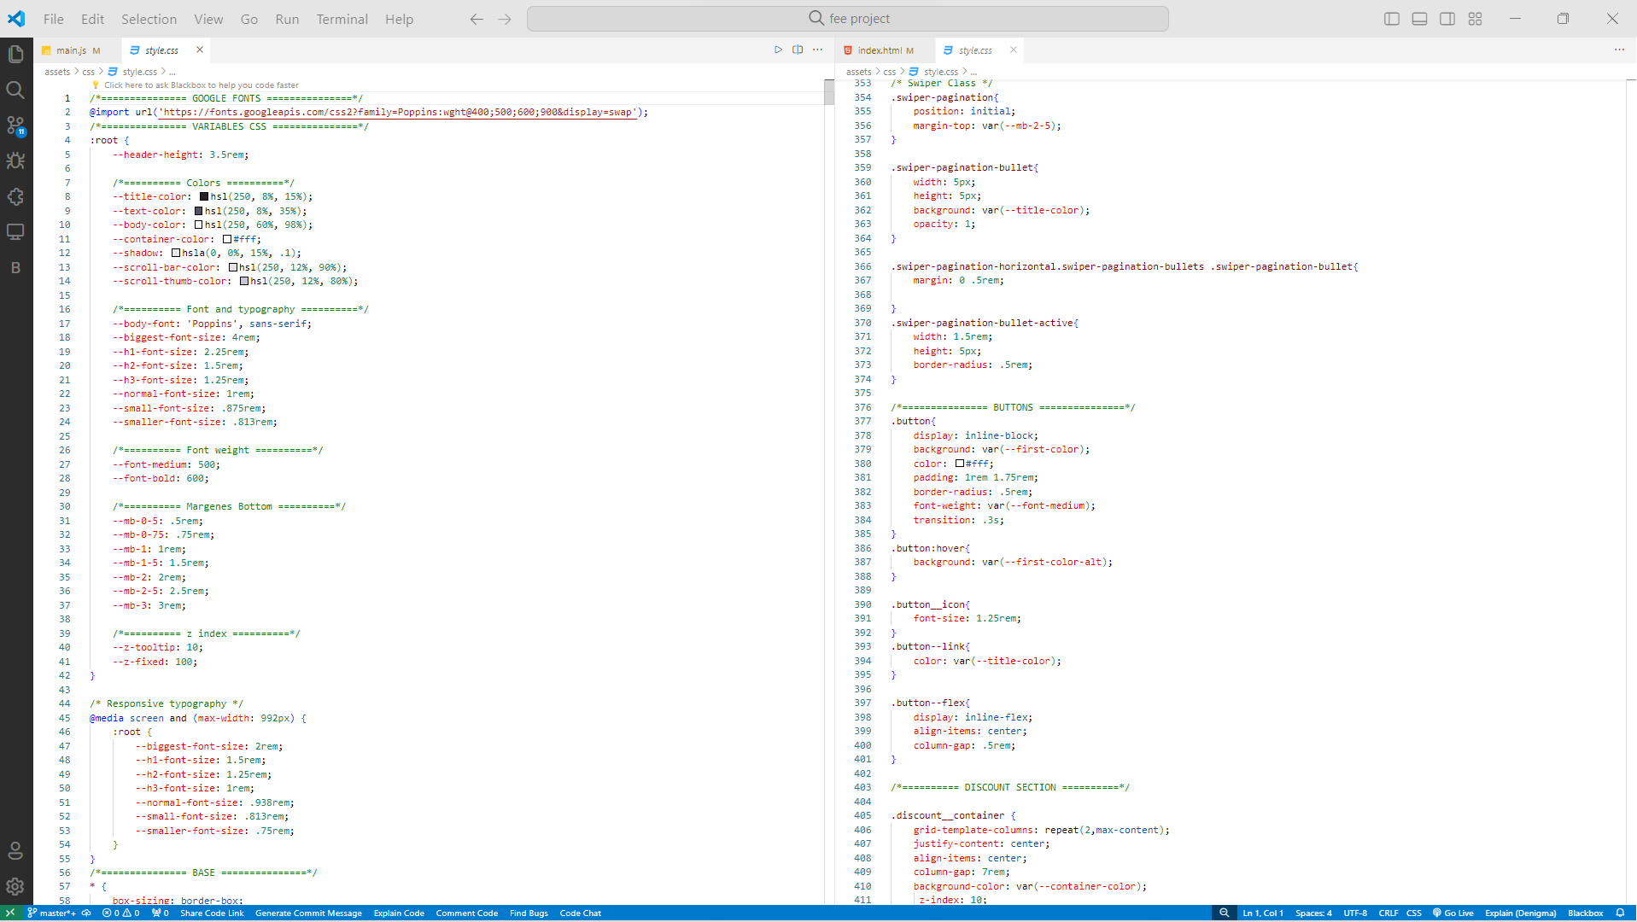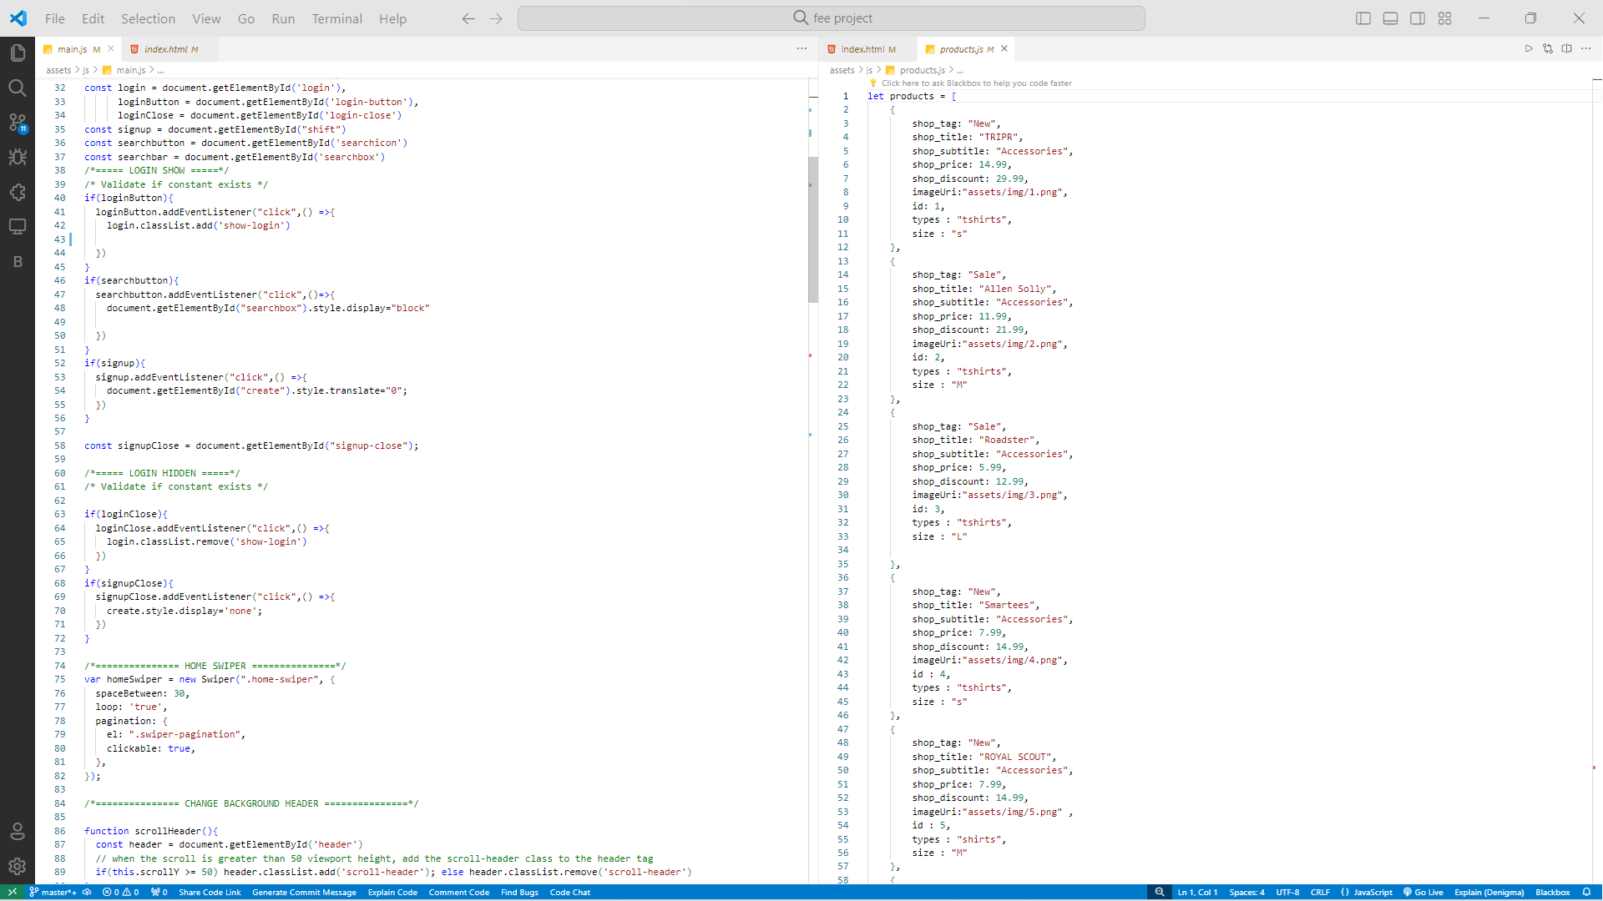

Figure 6.2 main.js

Figure 6.3 style.css